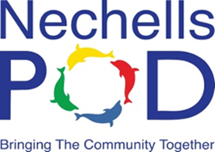
Nechells POD

NewsletteR
December 2019: Edition 27


Noran’s News

This is my last Noran’s News of the year, how quickly has this year gone? We have had a very busy time in 2019 at Nechells POD and have enjoyed some amazing events with the community such as the Great Get Together, the Mayor’s Weekend, lots of day trips, the Happy Healthy Holiday programme, our own live theatre and a dance production in the community room, it really has been an exciting year. Some of the year has been tinged with sadness as we have lost some of our lovely community members who were great supporters of Nechells POD and we miss them. However we have also had some lovely new additions with several babies arriving during 2019 so lots of first Christmases!!
We have continued to offer a range of courses through JCC and WEA as well as working with other partners and volunteers to provide lots of fun activities. All in all we have had a fabulous 2019 and are looking forward to this continuing in 2020. Our community residential will take place on 18th and 19th April 2020. We are going to Spinkhill as we did in 2018 so we know we will be well looked after and have a very special time together. The cost will be £30 per adult and £20 per child and this will include accommodation, food, transport and activities. There are a limited number of places available so if you are interested let POD staff know and start saving!

From January the newsletter will no longer have ‘Noran’s News’ but you will have ‘Rachel’s Round Up’ to keep you in touch with what is happening at Nechells POD.

I would like to take this opportunity to thank all our lovely POD participants for your support and friendship throughout 2019 and indeed since we set up Nechells POD in 2008. I am really proud to have been involved with such an amazing charity and to have been part of establishing a vibrant community hub. As you all know I am now quite an old lady so retirement beckons! I will be retiring from my post at Nechells POD at the end of January 2020 but hope to be able to continue as a trustee so you will still see me around, I am like the proverbial bad penny, always turning up! Of course I will have an opportunity to celebrate my retirement with you during the February half term holiday and I am looking forward to that plus I will be coming along to the residential.
Wishing you all a happy and peaceful Christmas and a wonder filled 2020!
Noran x


RECAP OF 2019 IN PHOTOGRAPHS
January  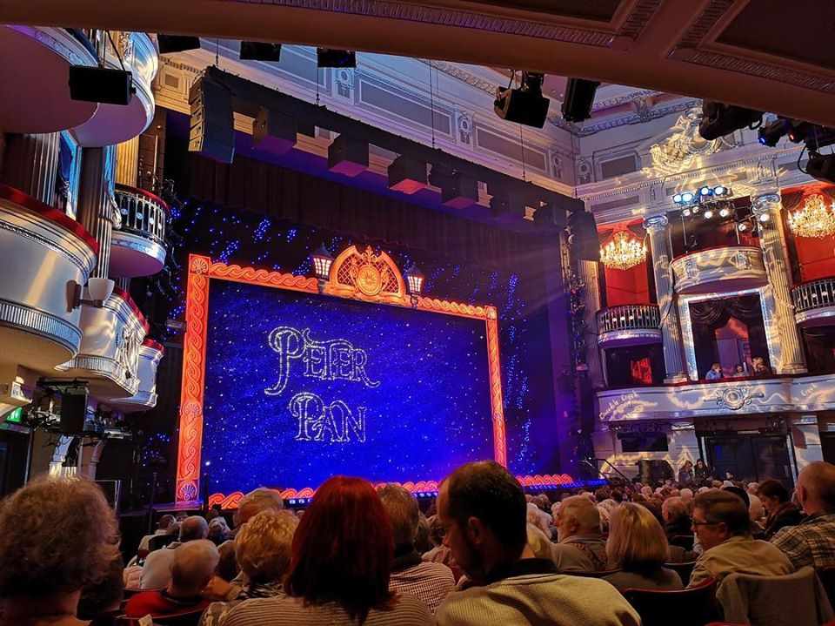 | February  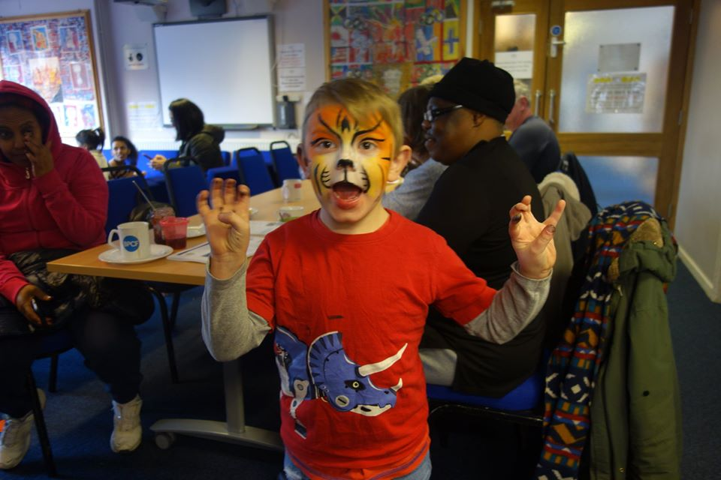 | March  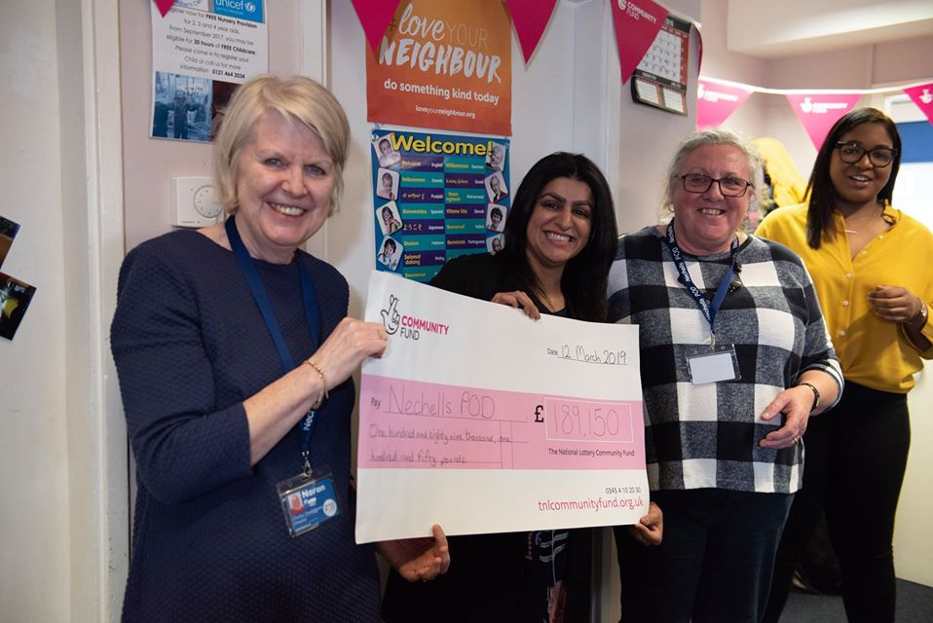
April  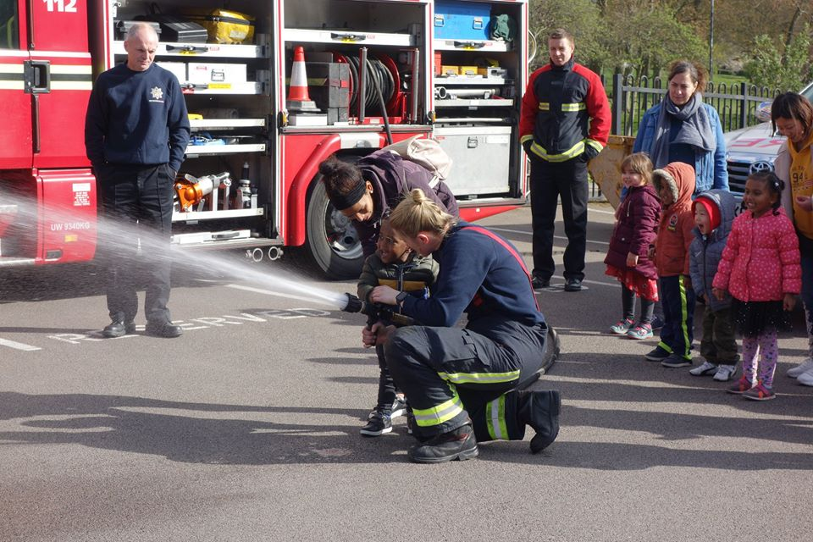 | May  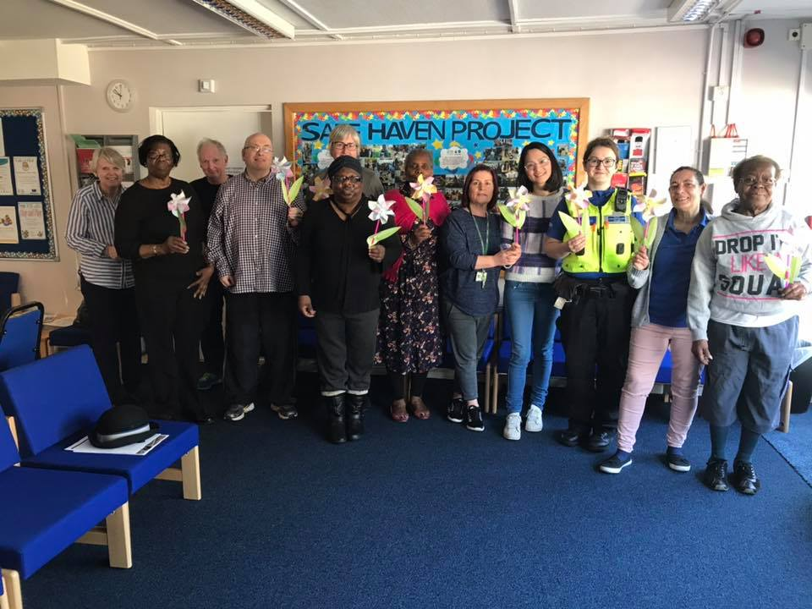 | June  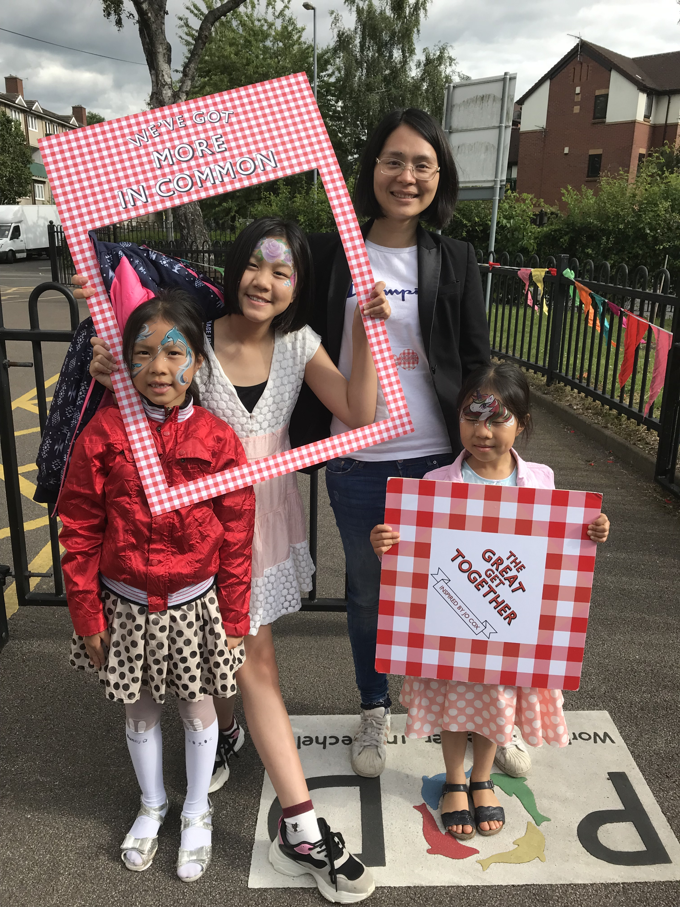
July  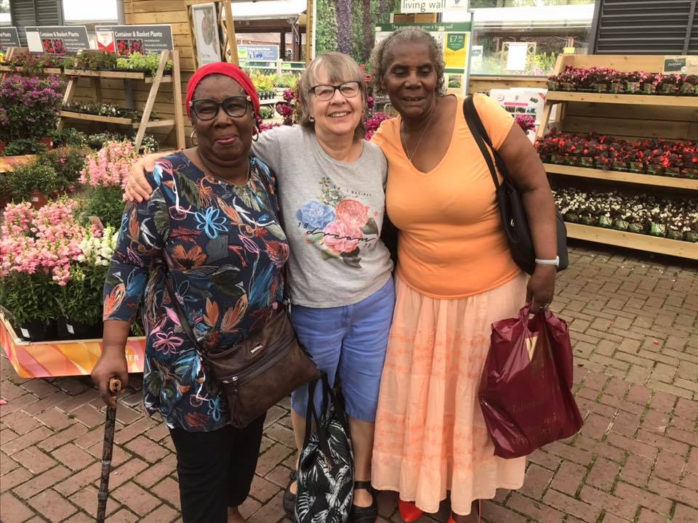 | August  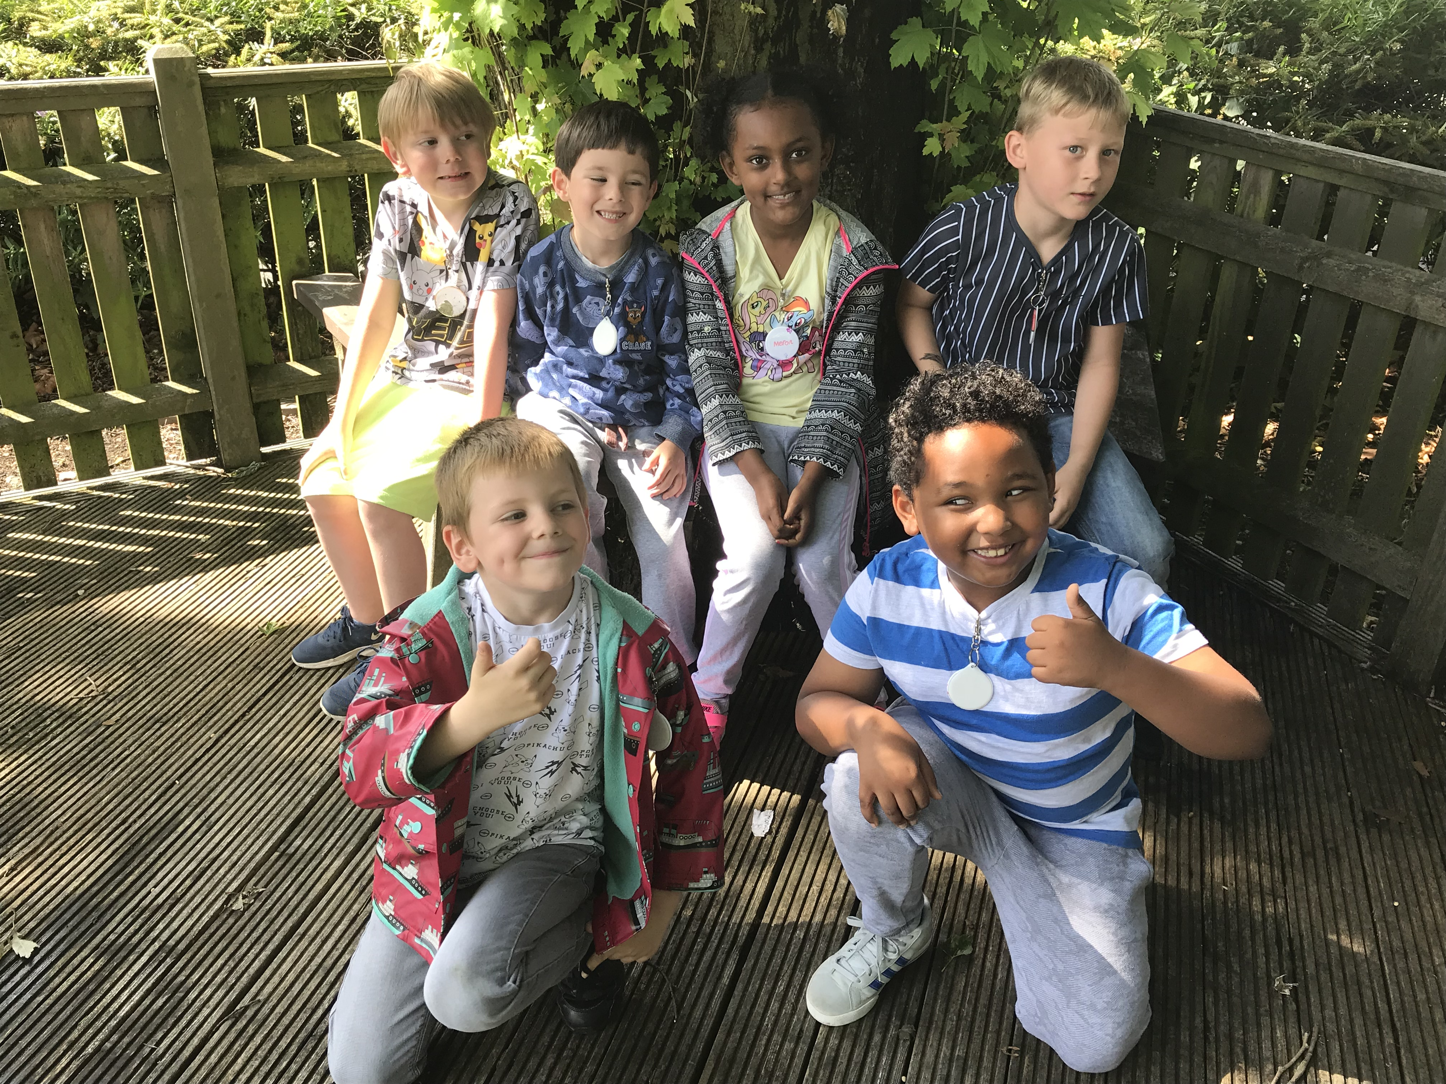 | September  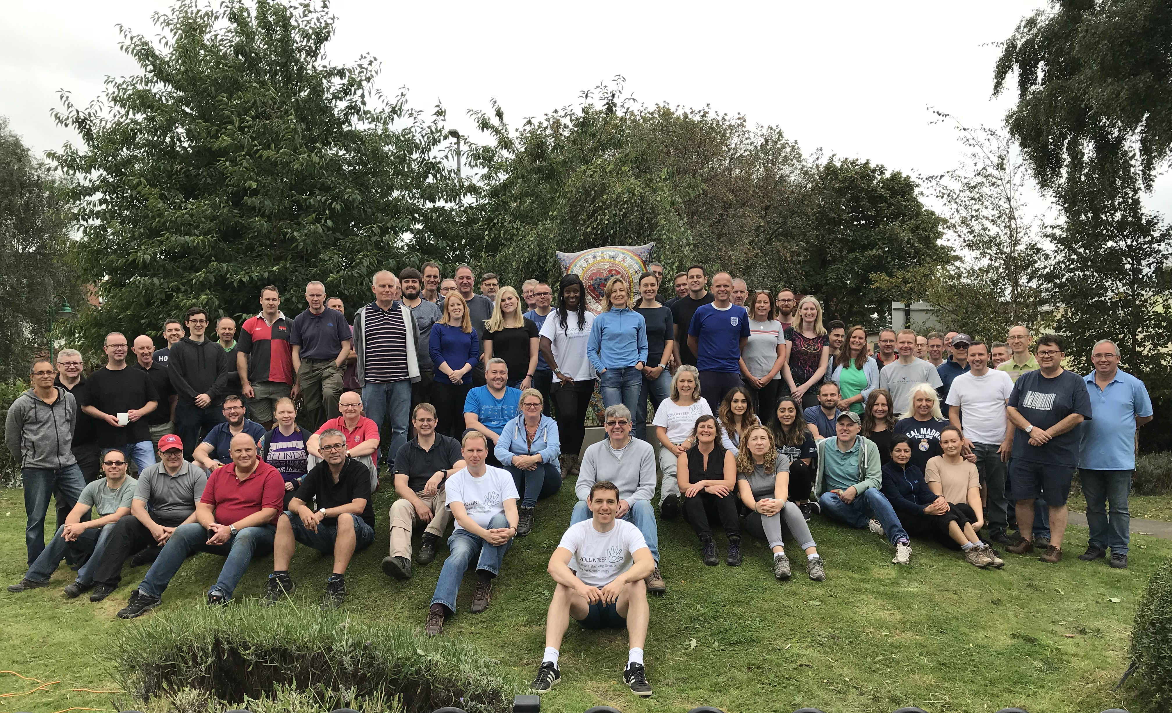
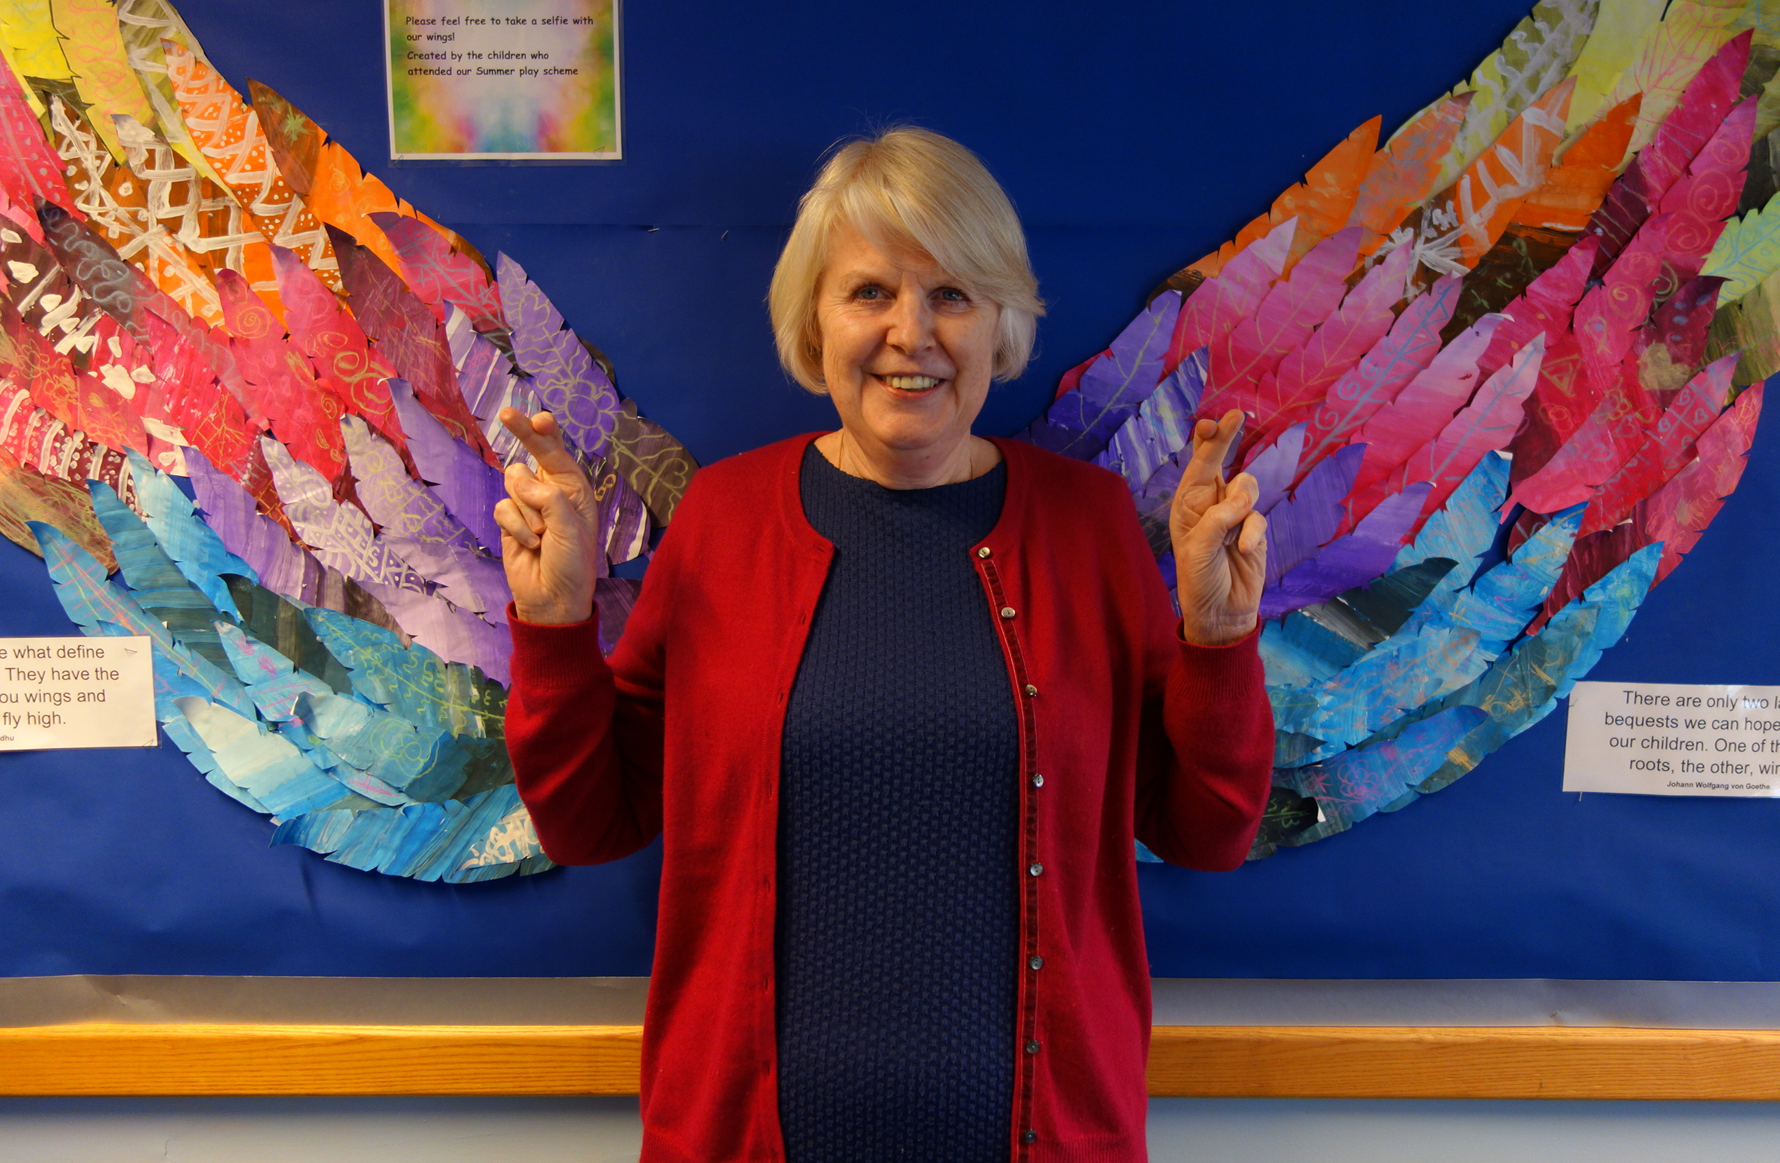  October | 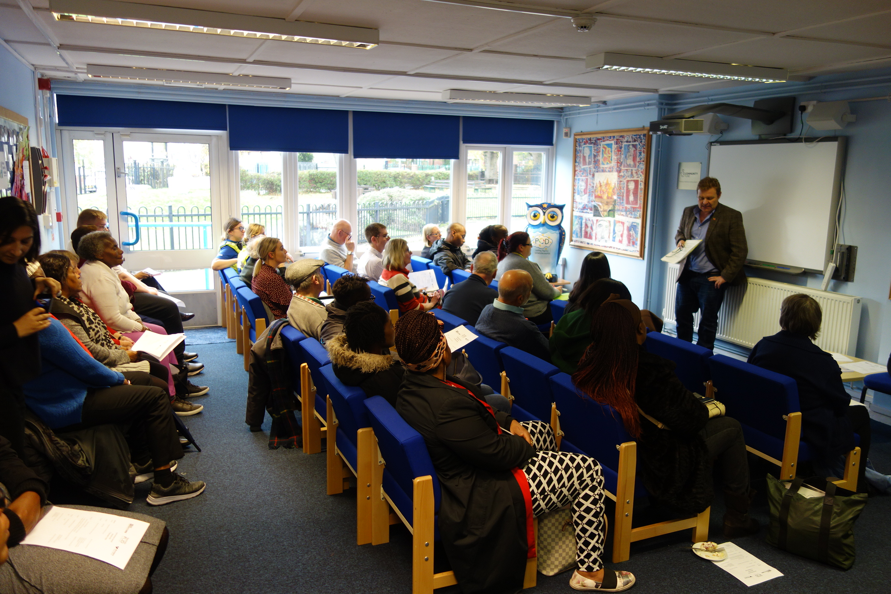  November | December  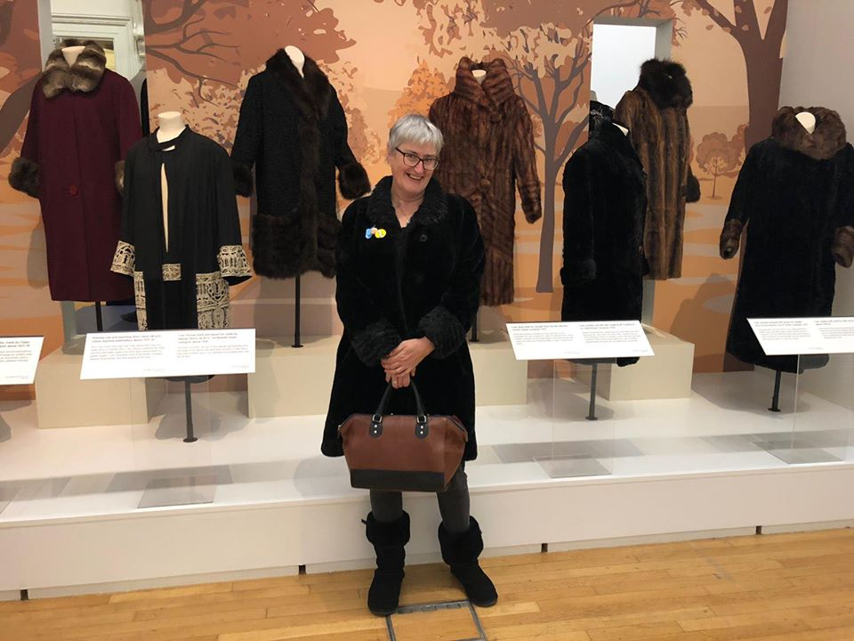
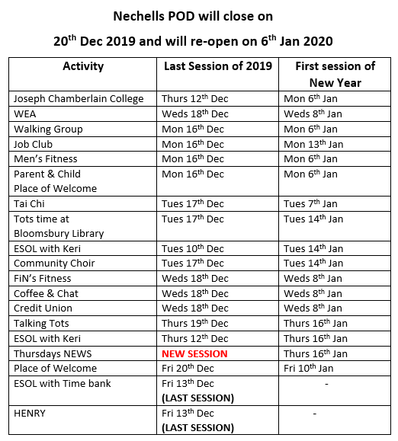




RECAP OF 2019 IN PHOTOGRAPHS
Contact Us
Nechells POD
28 Oliver Street
Nechells, B7 4NX
Telephone: 0121 681 2173
Website: nechellspod.co.uk
@nechellspod
@NechellsPOD
@NechellsPOD

