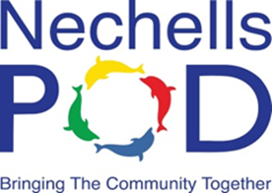
Nechells POD

NewsletteR
All of Us Project Launch
April 2019: Edition 21

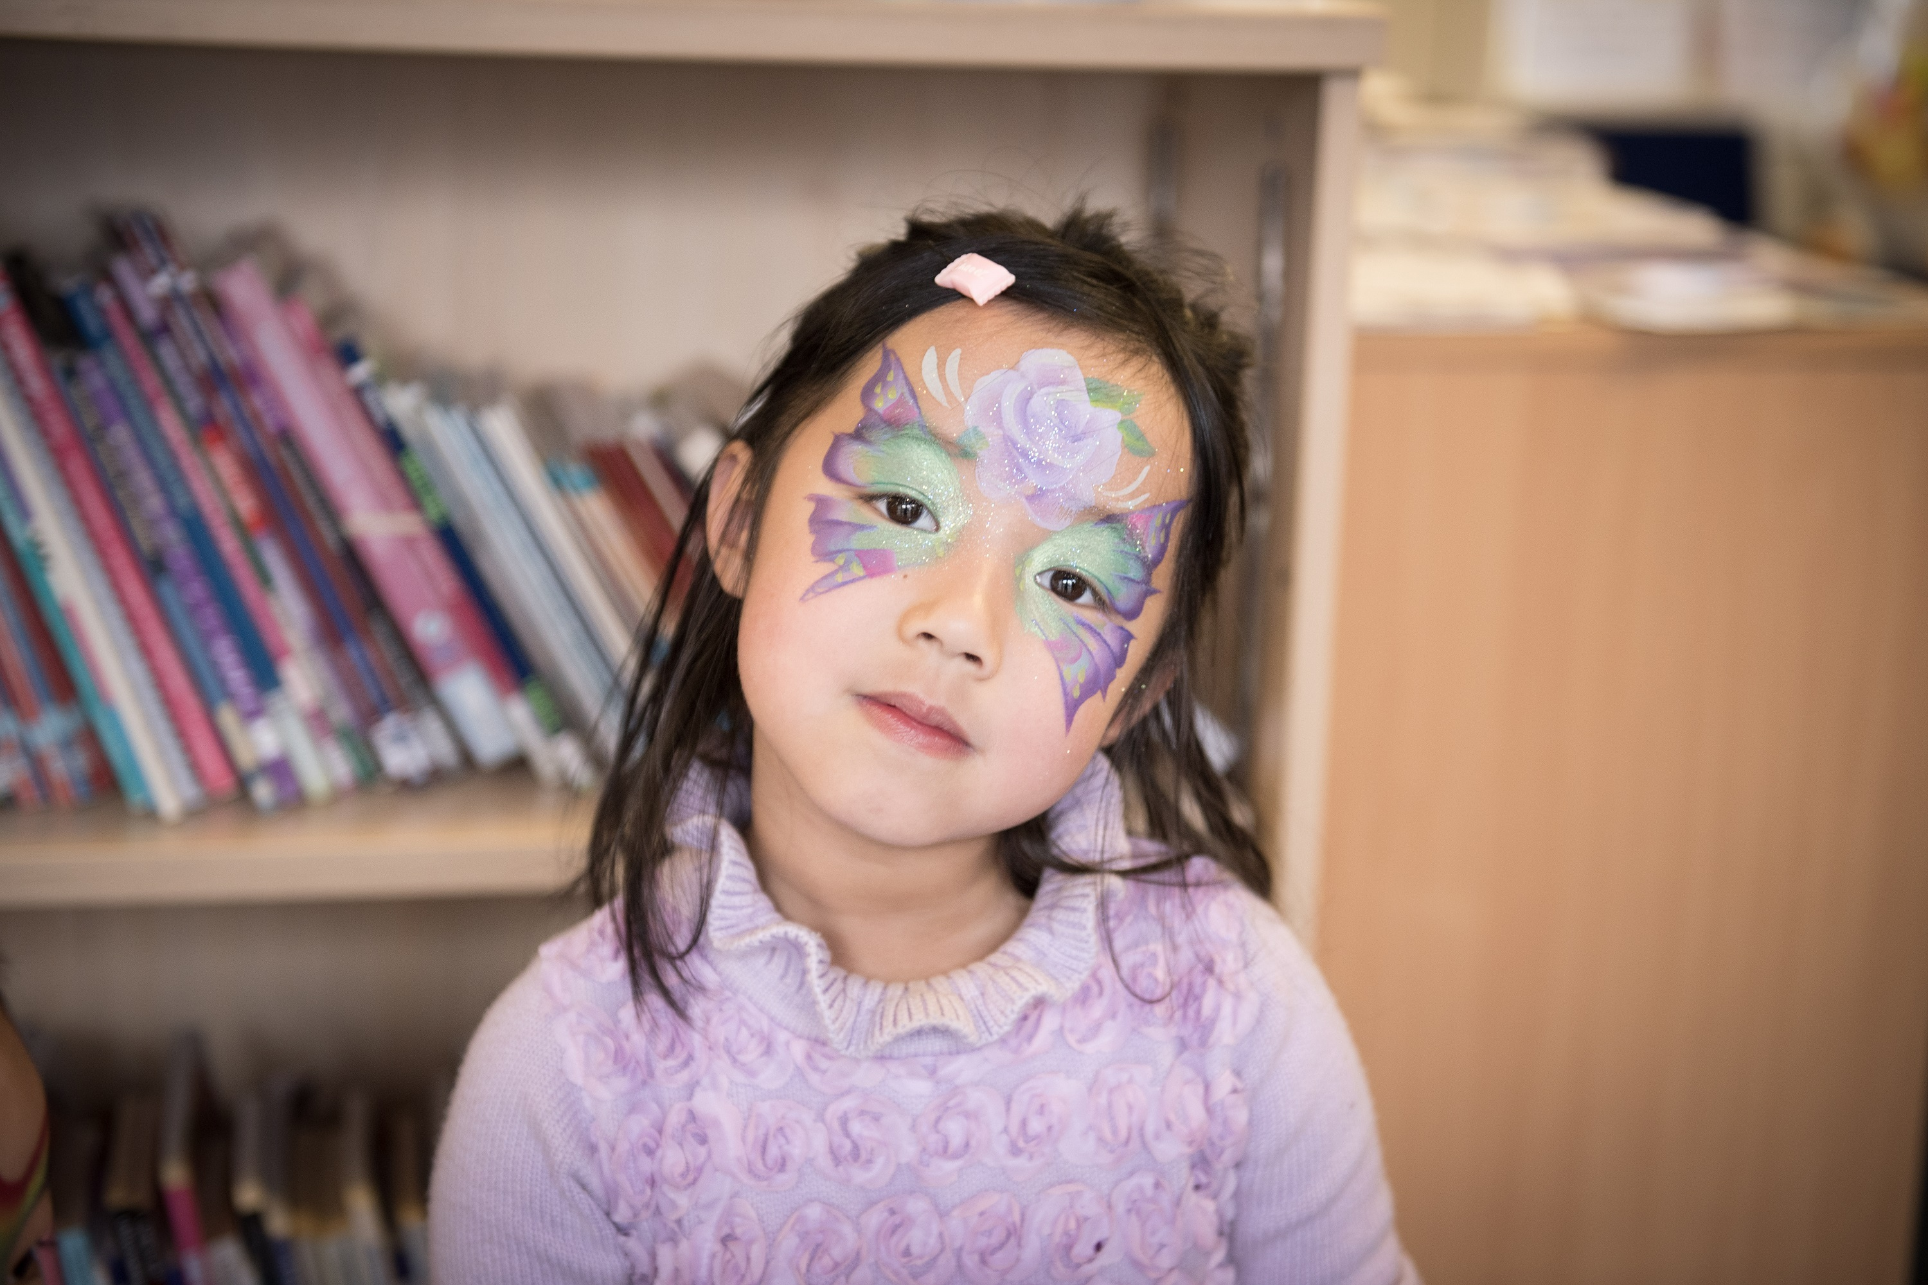
On Saturday 16th March 2019 we launched the All of Us Project. It was a great event with lots of Nechells residents joining us. We are particularly grateful to Shabana Mahmood MP who led the launch and Giselle Brown from the Lottery who brought along the big cheque!!

We had lots of fun activities taking place throughout the morning and because everyone enjoyed themselves so much we will be running the same activities during the Great Get Together-Permission to Party event on Friday 21th June from 3pm to 6pm.

On Friday 5th April five candidates who have applied for the Project Manager post will be joining us at Place of Welcome and we will then conduct the formal interviews on Tuesday 9th April. This is a really important appointment as the successful person will be leading Nechells POD into the future. We have got some really strong candidates so we are sure that we will be able to appoint the right person. I am sure you will enjoy meeting our visitors and make them very welcome.

Community Lunch tickets are now available for Friday 12th April. Please note Adults only, cost £2 per person.

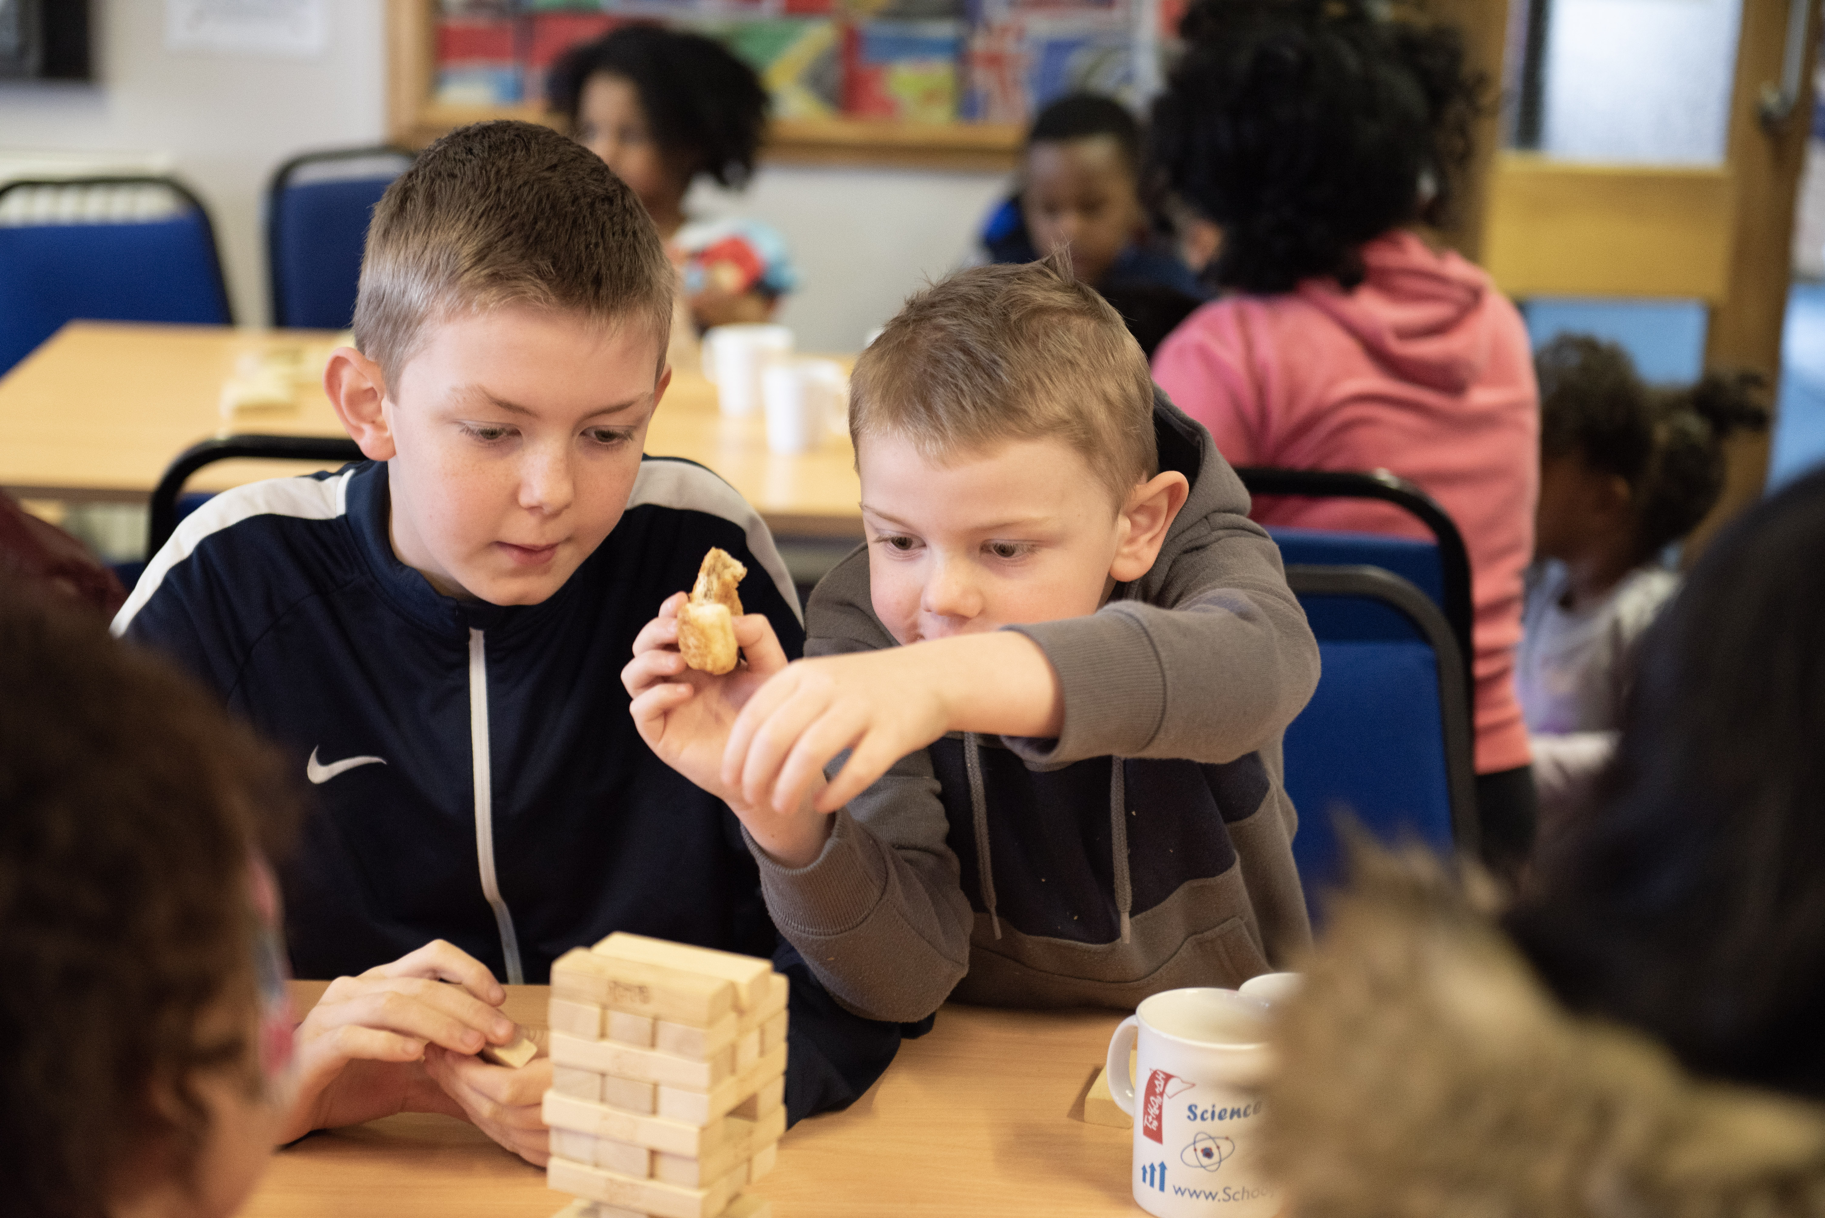

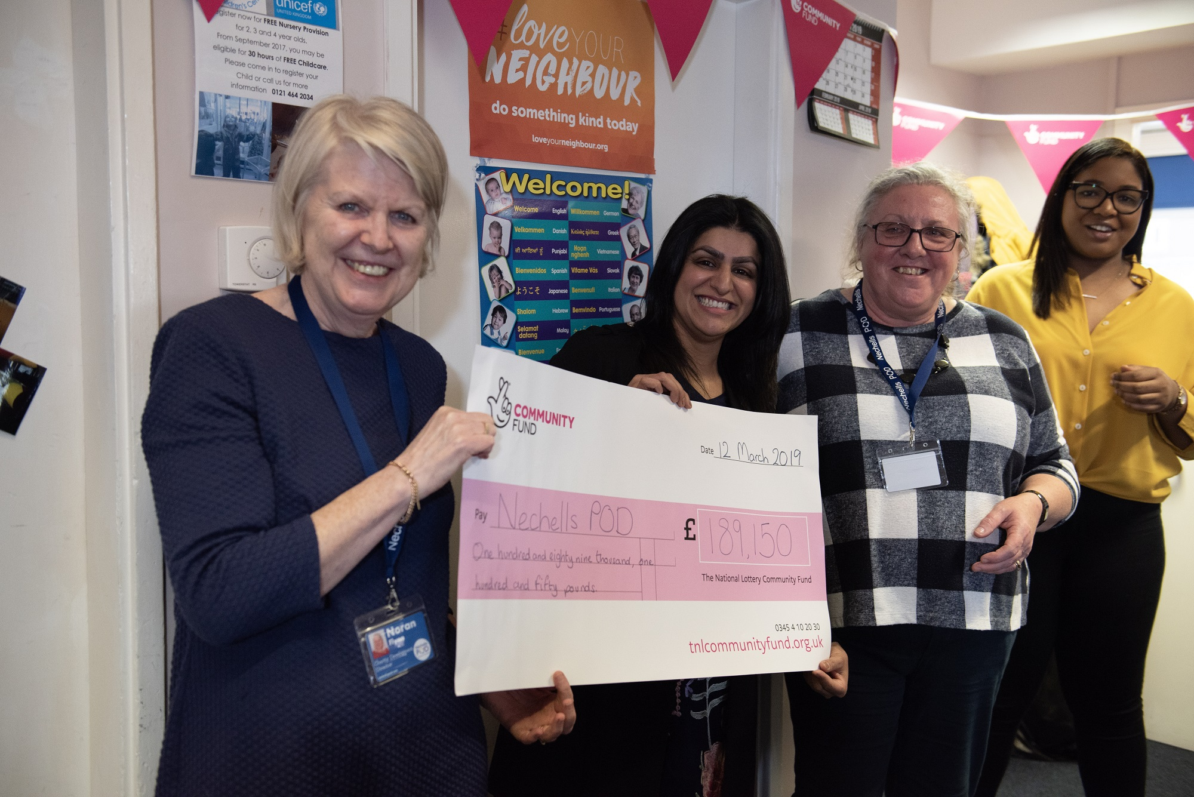
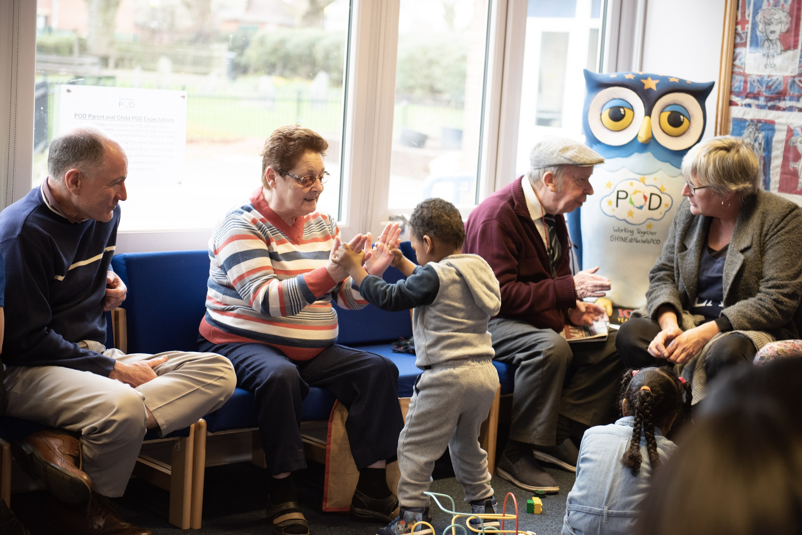
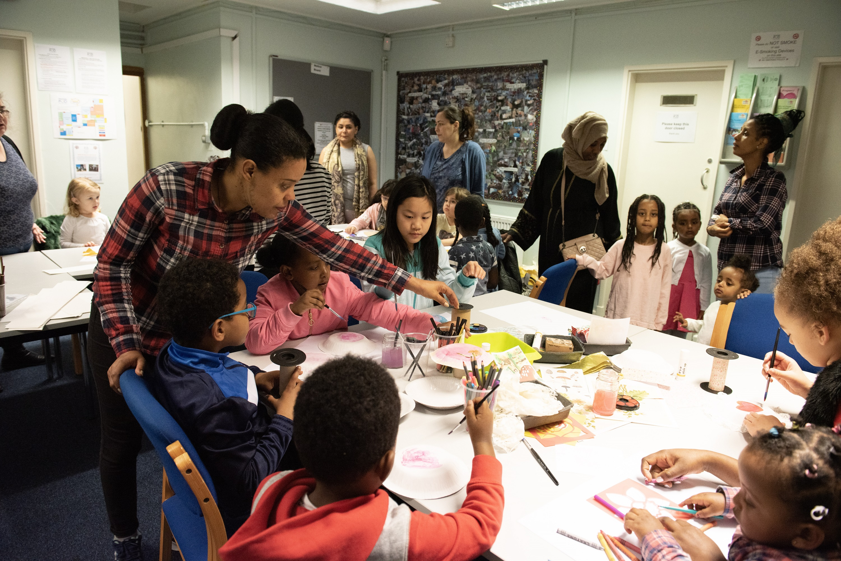
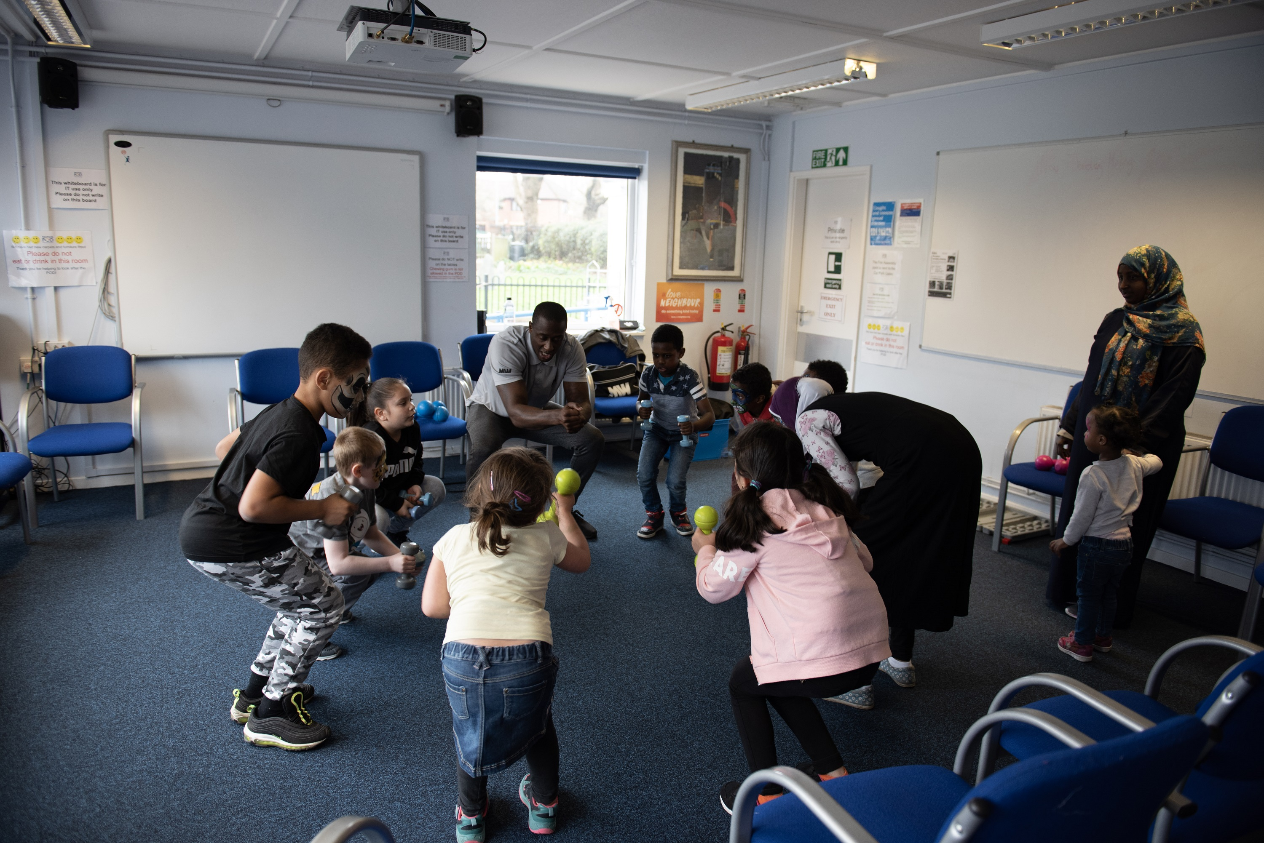
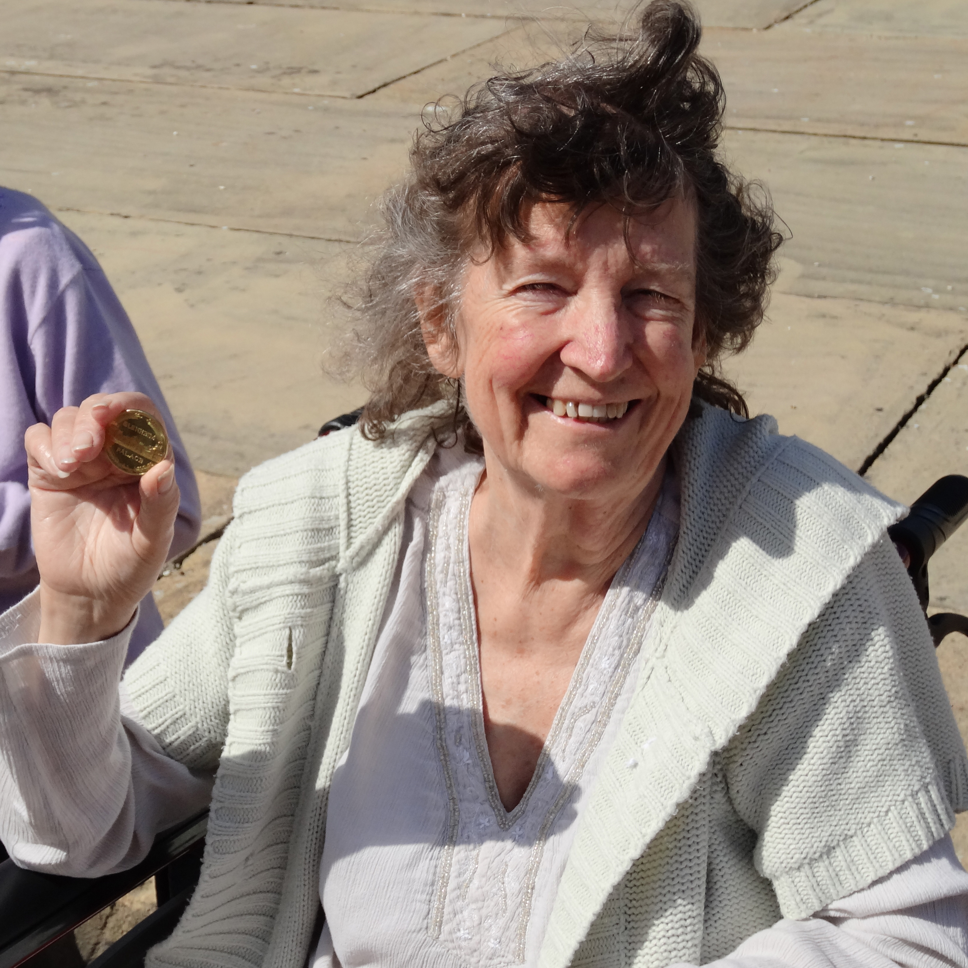
Sad News
We were really sad to hear that Sylvia Pickard has passed away after a long illness. Sylvia was one of our first volunteers at Nechells POD, helping with the Parent and Child Language sessions. She also encouraged lots of Nechells residents to join in POD activities and was always welcoming and friendly. Most of all we will remember Sylvia for her generosity and her skills as a cook, she cooked amazing food which she brought in to share with everyone. We will miss Sylvia’s smile and support!

Weekly Activities
Monday
- Walking Group 9:15-10:30
- ICT drop in session 9:30 – 12:00 (2nd Monday of the month)
- Job Club 9:00-11:00
- Safe & Sound 10:00 – 12:00
- Place of Welcome stay and play 1:00 – 2:30

Tuesday
- Tai Chi 9:30-10:30
- ESOL 10:30-12:00
- Tots Time 11:00-12:00
- Yoga 13:00 – 14:00

Wednesday
- FiN Fitness 10:30-11:30
- Coffee & Chat 11:30-12:30
- Credit Union 11:30 – 12:00

Thursday
- Parent and Child Language Course 9:00-10:30
- Parent and Child Language Course 10:45 – 12:15
- ESOL-- Kevin & Keri 10:30-12:00
Friday
- Place of Welcome 9:00-11:00
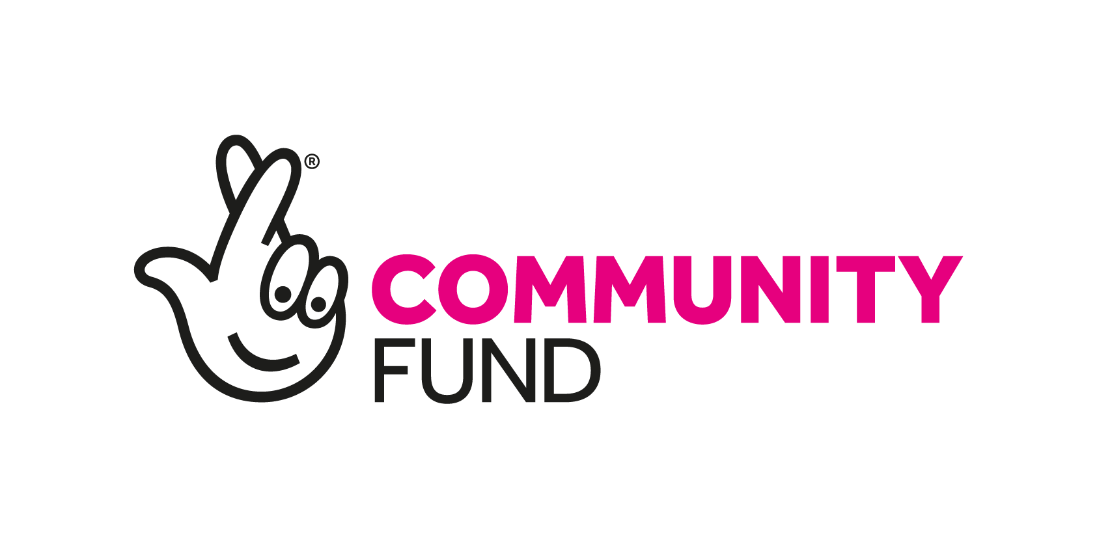
I thought it would be useful if people who use Nechells POD knew why we set up the charity and how we see it developing in the future. Everything we do is in response to what the community tell us and what activities and support they suggest they would like at Nechells POD.
Our vision is to develop the skills and capacity of the Nechells community to help them meet their needs and participate fully in society.
In our constitution we say we will:

- Promote social inclusion and make sure no one in the Nechells community feels excluded.
- Advance education, training and development for all local residents

As part of our staff training we looked at our values and agreed:

For ourselves we value: - Integrity, Consistency & Responsibility.

Together, as a team we value: - Leadership, Motivation, Appreciation, Support,
Empowerment, Unity, Encouragement, Collaboration, Inspiration.

Values we hold for our Community include: - Welcoming, Fairness, Warmth,
Responsiveness, Kindness, Cultural Understanding, Friendliness.

We value Inclusivity which comprises: - Diversity, Tolerance, Acceptance, being non-judgmental, Equality, Respect, Understanding &amp; Openness
For Those in Need we will be: - Proactive, Sensitive, Compassionate, Helpful, Nurturing
It would be very interesting to know what you, as POD participants, value and what is important to you in your community.

Best Wishes
Noran
Noran’s News

@NechellsPOD
@nechellspod
@NechellsPOD



Contact Us
Nechells POD

28 Oliver Street
Nechells, B7 4NX
Telephone: 0121 681 2173
Website: www.nechellspod.co.uk/

